# FCFS:

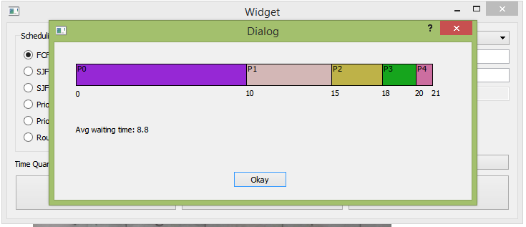

# SJF(No preemption)

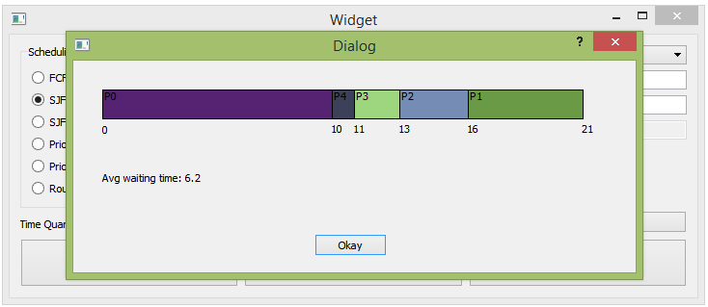

# SJF (Preemption)

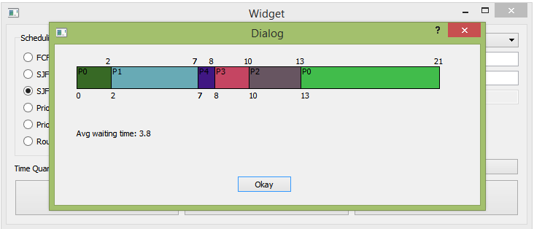

# Priority(No preemption)

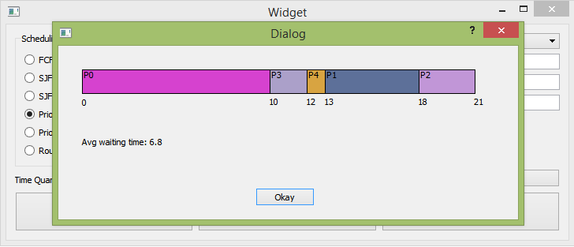

# Priority (Preemption)

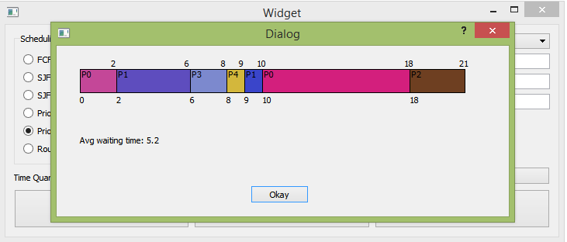

# Round Robin

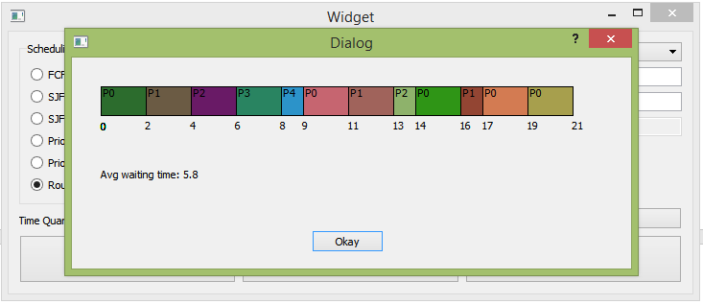

Quick Notes:

* If you want to delete a certain process choose its index from the list then press delete. (indexing starts from 0)
* I am assuming optimum CPU usage (no idle time & and processes start at time 0)
* If you want to just start fresh press clear processes.
* If you don’t like the colors resize the window or alt + tab and the colors will change :D